Tested automation scripts

Please read for approach and considerations –

Tools Used for Prerequisites

* Used Selenium with Java Language Approach, Tools used Eclipse and Language used Java.
* Please download Eclipse from <https://www.eclipse.org/downloads/>
* Please install latest JDK(Java) from [www.oracle.com](http://www.oracle.com)
* Import selenium libraries for web drivers

Approach –

1. Identified Automation scenarios –
2. TC01_Profile User Registration
3. TC02_Login
4. TC03_Logout
5. TC04_Profile Update
6. TC05_Password Change
7. TC06_Comments on Cars
8. Created separate classes for each test case. In same class only main function with logic implemented, Tried for Reusability of functions like Login Function, Logout Function, chrome driver initiation with constructors creation and use in other classes as per test case requirement. But got errors multiple time for Webdriver driver, won’t able to fit in those kind of structures so need more research and analysis from my end but due to limited time, I have created separate classes for now.
9. Also for now test data are hardcoded due to limited time constraint but I know we can use Apache POI for csv file for login inputs and also we can use some random user id, name and password creation functions for data provision every time use.
10. For Report – I have printed in output only for now but using TestNG we can print in excel.
11. For Test suite run we can use CICD tool for Automatic execution in night, Parallel test execution.
12. Considered now for Chrome driver only but we can use Geckodriver for Firefox browser run cases and we can check for other browsers too using their drivers

**I know all above things as using existing framework till now, but when you asked to create new Framework I learned many things and few more I need to add to build one robust hybrid framework.**

**Please give me opportunity for Interview to check at least my skills and then decide.**

**I have uploaded Eclipse Java Project on GITHUB please import and run them.**

Please find below screenshots for executed program for your reference.

1. Registration Automation Test case and Result

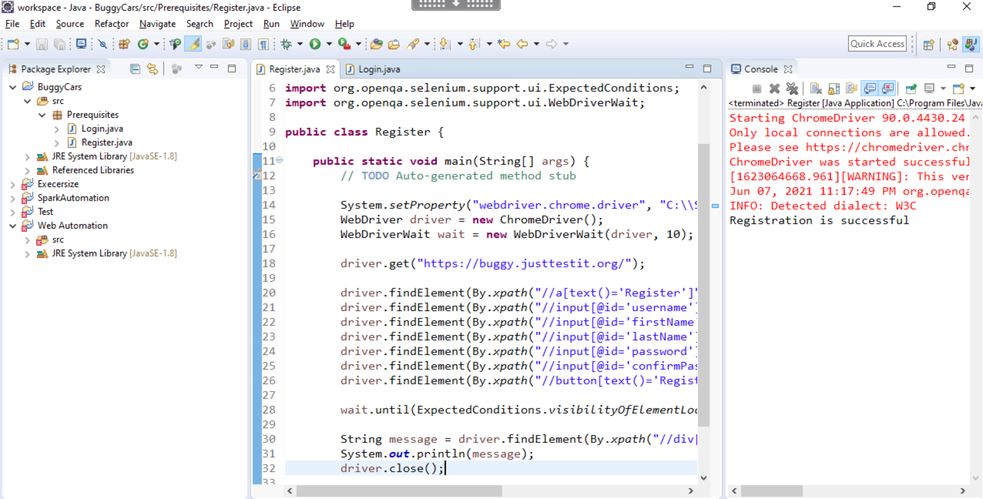

1. Login Test case

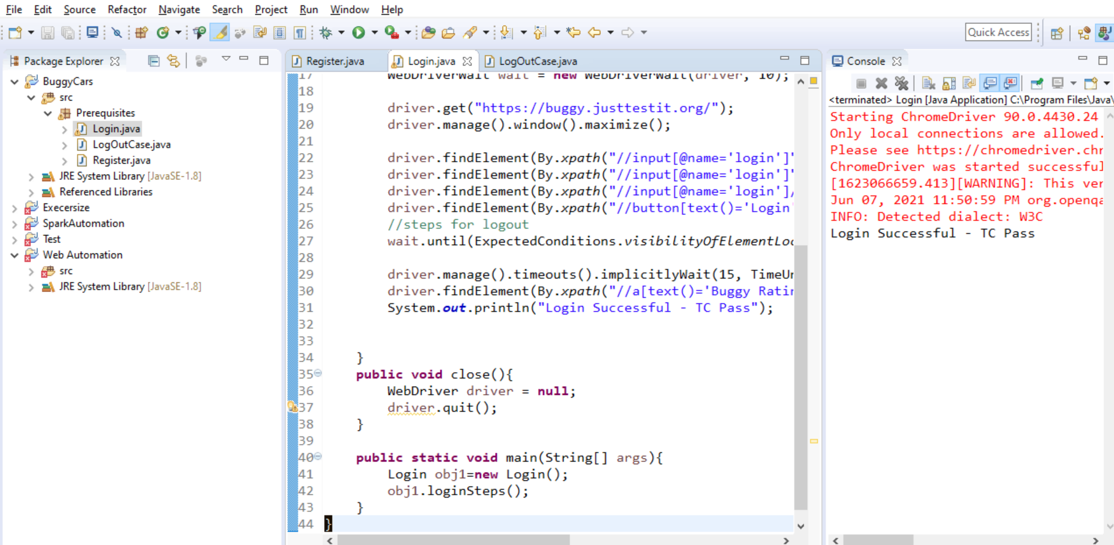

1. Logout Test Case

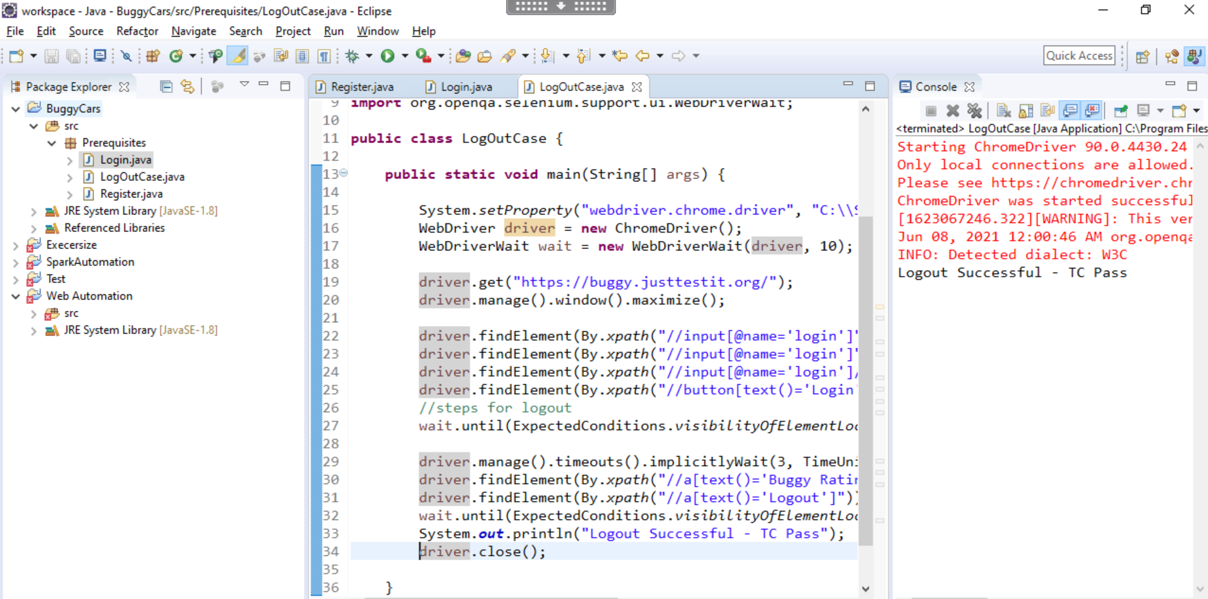

1. Profile Update case

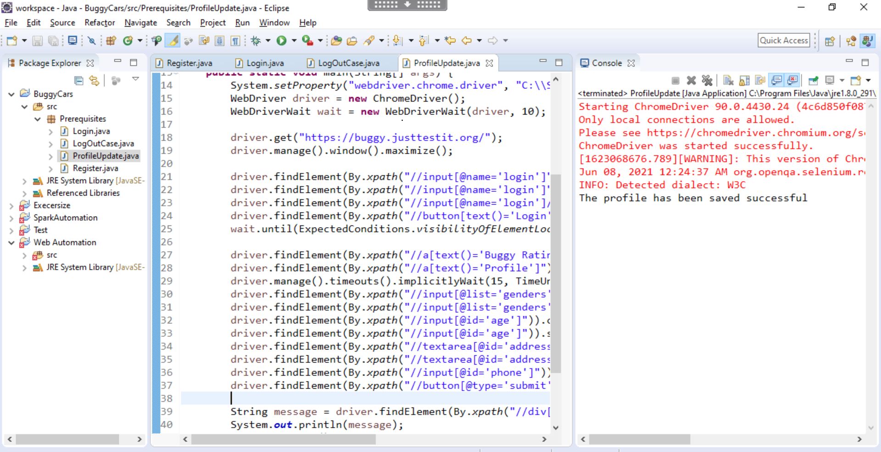

1. Password Change Case